CSA0998-PROGRAMMING IN JAVA

DAY-3

PROGRAMS

Name:K.Sree Durga Geethika

Reg.no:192111472

Dept:CSE

1. Write a java program to find factorial of given number using oops concept.

Program:

import java.util.\*;

class factorial

{

void fact(int n)

{

int fact=1,i;

for(i=1;i<n;i++)

{

fact=fact\*i;

}

System.out.println("factorial is:"+fact);

}

}

class factor

{

public static void main(String args[])

{

int number;

Scanner s=new Scanner(System.in);

System.out.println("enter the number");

number=s.nextInt();

factorial obj=new factorial();

obj.fact(number);

}

}

Output:

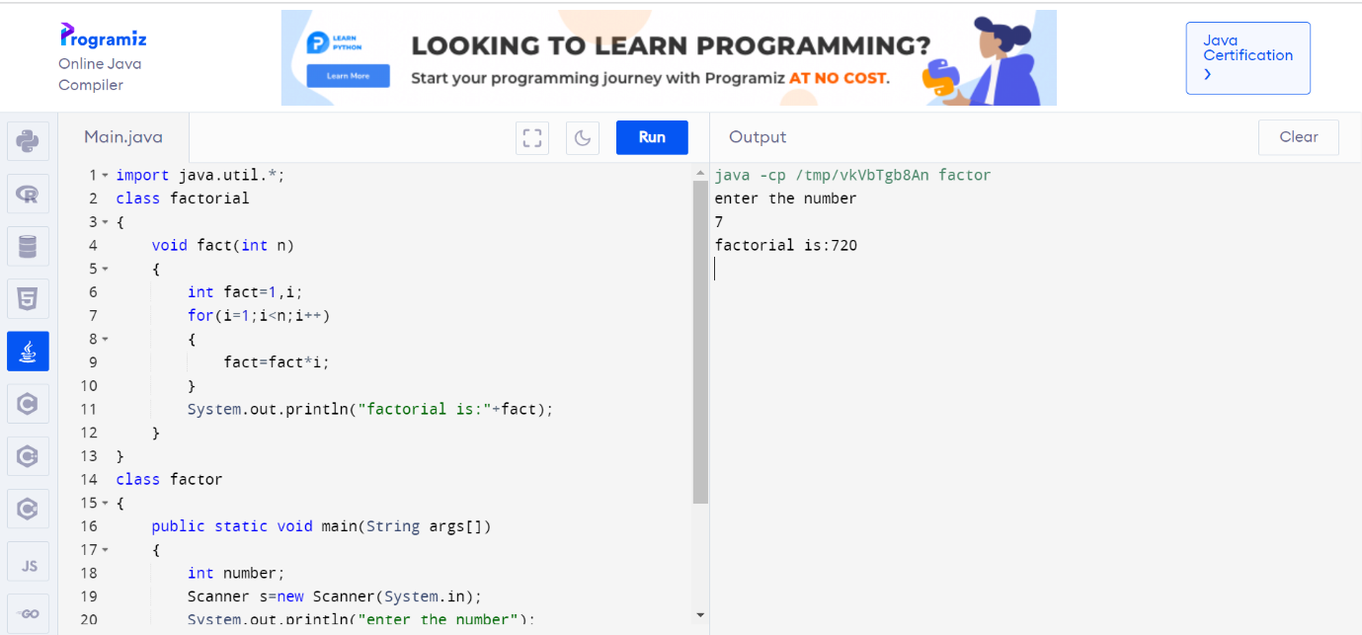

1. Write a java program to find simple interest using constructor.

Program:

import java.util.\*;

public class roi

{

int p,y,r;

roi(int a,int b,int c)

{

p=a;

y=b;

r=c;

}

void interest()

{

int roi=p\*y\*r/100;

System.out.println("interest="+roi);

}

public static void main(String args[])

{

int p,y,r;

Scanner s=new Scanner(System.in);

System.out.println("enter princple amount");

p=s.nextInt();

System.out.println("enter no of years");

y=s.nextInt();

System.out.println("enter rate of interest");

r=s.nextInt();

roi r1=new roi(p,y,r);

r1.interest();

}

}

Output:

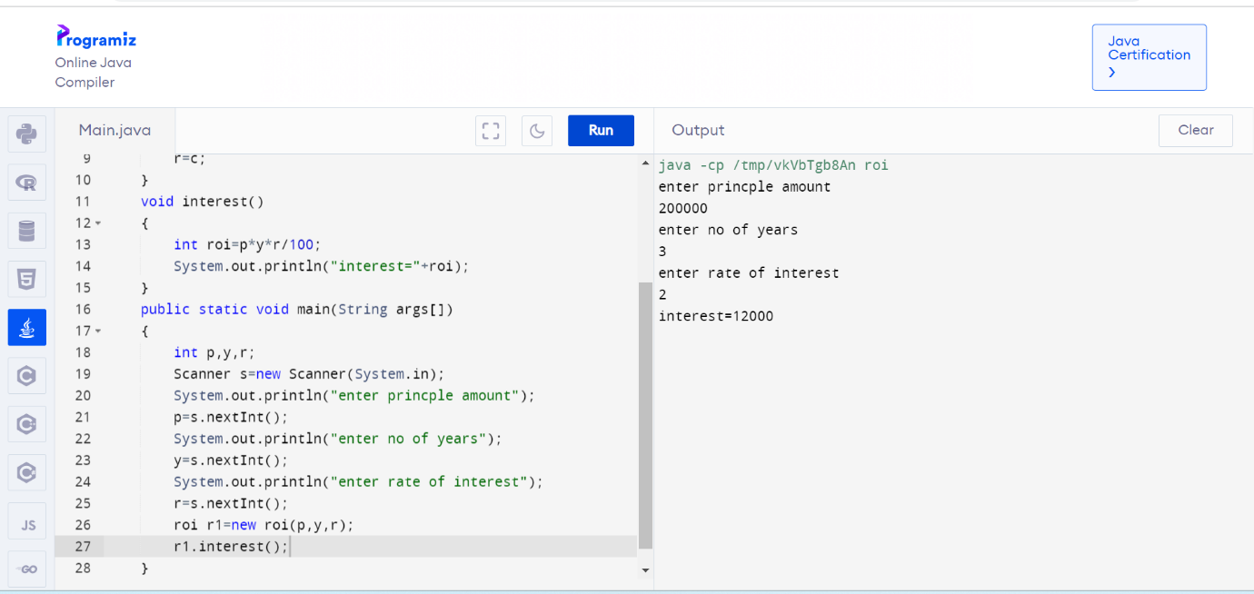

1. Polymorphism program:

Program:

class over

{